Media Relations (PRAD 562) Andrew Zamorski

February 3, 2016 Melanie Mills

**Media Coverage Assignment**

**Nonni’s Dark Chocolate Almond THINaddictives**

1. **Methodology**

***Overview***

The present study was completed to understand how Nonni’s THINaddictives is being perceived by the public, what interests and conversation trends are driving social action, and most importantly, to identify what specific content is driving engagement to successfully design a campaign for the client’s new product. Crimson Hexagon was used to obtain insights from social data over a one year period (from Jan. 29, 2015 to Jan. 29, 2016), and other conventional web searches were later completed to gain better understanding about specific findings. The two monitors from Crimson Hexagon used for this study were “Nonni's THINaddictives” and “Healthy Snacking” which included the keywords “Thinaddictives”, “Thinaddictive”, “Thin addictives”, “Thin addictive” AND “Snack”, “Snacking”, “Snacks”, “healthy”, “light”, “health conscious”, “natural ingredients”,“guilt-free” respectively.

Finding that “health” is a main topic of interest for our target audience, and THINaddictives are considered a healthier choice when it comes to snacking, we decided to run a conventional web search through Google and Bing using the keywords “health”, “Nonni’s” and “magazine”. The following media outlets were identified:

* Fitness Magazine
* Health Magazine
* Cooking Light Magazine
* Shape Magazine
* MSN- Health and Fitness
* TODAY- Health and Wellness.

1. **Analysis of Media**

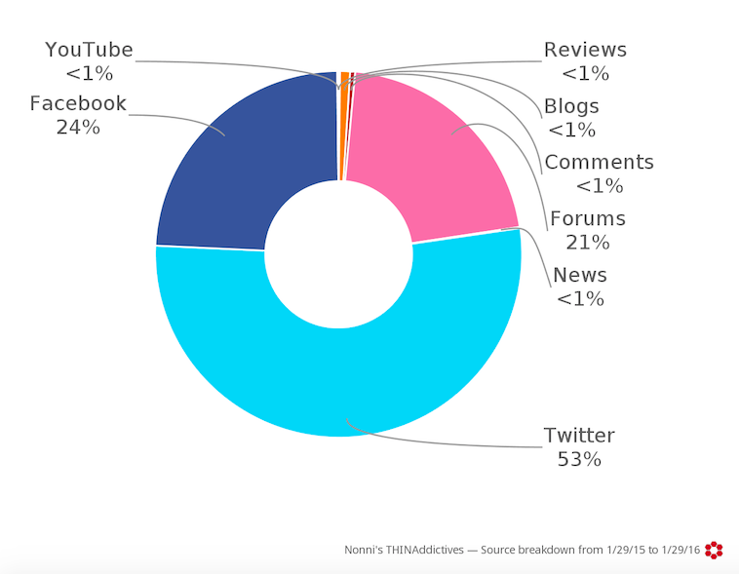

***Analysis of “Nonni’s THINaddictives”***

“Nonni’s THINaddictives” monitor analysis is important because it allows us to identify conversation trends around the brand and the product, product perceptions, and learn about our target audience’s related interests.

Over the course of one year, January 2015 to January 2016, a total of 1,881 mentions related to Nonni’s THINaddictives were posted in social media, 96% having a positive or neutral tone. Twitter (53%) and Facebook (24%) were the sources where the majority of postings came from. The remaining 23% was divided between YouTube, news, forums, blogs, comments, and reviews. This volume of coverage however is considerably low compared to Nonni’s THINaddictives’ competitors (over 190,000 posts throughout the year) and thus, improving social media engagement is a major opportunity for our client. An important factor to consider here that will help us develop our campaign’s strategy is Twitter’s most influential authors. Crimson Hexagon notes that the top ten authors are all female bloggers, each with over 10K Twitter followers, generating 5.4 million potential impressions.

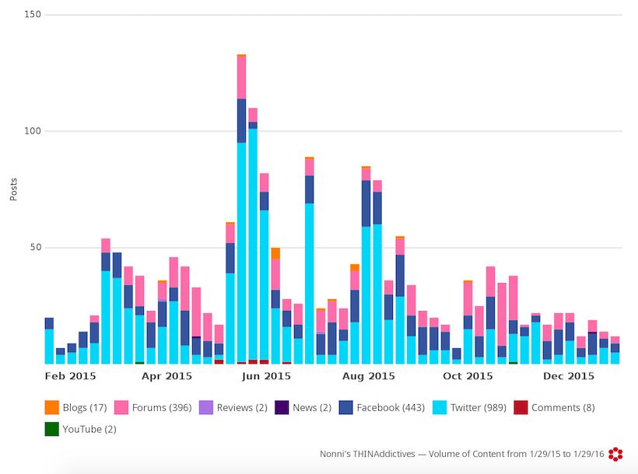Mentions of Nonni’s THINAddictives on social media (see figure below) averaged less than 60 posts per week with shifts in coverage throughout the month on June, mid July and then again in mid August. These spikes happened around the time when the new Tropical Mango Coconut THINaddictives were launched and contests were created to win free samples. Mentions throughout the year were mostly posted after 4:00p.m, with a larger volume happening during midnight.

The media audit shows demographic results that are aligned with our client’s target audience: 85% of the postings come from females and 15% come from men. New York (12%), Massachusetts (11%) and Pennsylvania (11%) are the top cities where these posts were generated, followed by Florida (7%), California (6%), and Texas (5%).

***Analysis of “Healthy Snacking”***

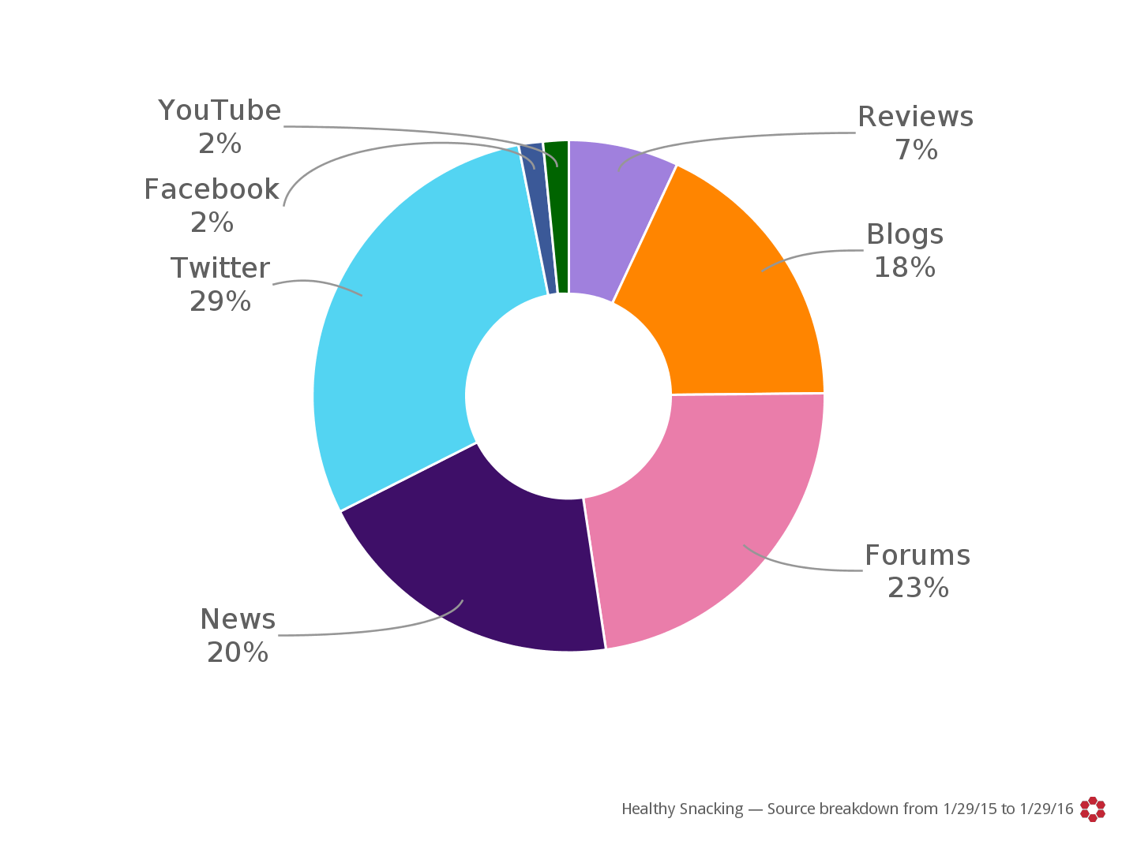It was important to also take a look at Crimson Hexagon for the social media coverage on healthy snacking. By looking at the types of communication, the affinities of the people posting to social media, as well as their demographics, it will be easier to target healthy snacking consumers should we choose to go this route with the Dark Chocolate Almond THINaddictives.

From January 2015 through January 2016, there were over 810,000 mentions of healthy snacking with almost 80% having a positive or neutral tone. The majority (29%) of the postings came from a single source Twitter (see figure above), while about 60% was divided among news sources, blog postings or forums including body building, weight loss, and other fitness websites. Healthy snacking is an evergreen topic; therefore it is mentioned fluidly throughout the year with a few spikes near the holidays or before summer. It is also relatively constant throughout the day with heavier amounts of posting in the late afternoon and through the night. This would be a great time to mention the healthy qualities of Nonni’s as many people would be looking for a healthy snack in the afternoon or after dinner.

The demographics of the healthy snacking social media audit align closely with Nonni’s demographics. Crimson Hexagon notes that 66% of the posts come from females while 34% are from males. Their top affinities are blogging, nutrition, celebrities, recipes, snapchat, parenting, and coupons. Some additional affinities associated with this group are cooking, being a mom, weight loss, chefs, and high school. On the alternate side, the affinities that have the least amount of identifiable interest with this group are sports such as soccer, baseball, and basketball, celebrities such as Justin Bieber, One Direction members, and Miley Cyrus and other interests such as fashion, science and technology, and video games. The top locations from where the social media postings originated largely follow Nonni’s target audience (Dallas, Chicago, New York/New Jersey) with California (12%) as the largest supplier followed by New York (10%), Texas (7%), Florida (6%), and Illinois (4%).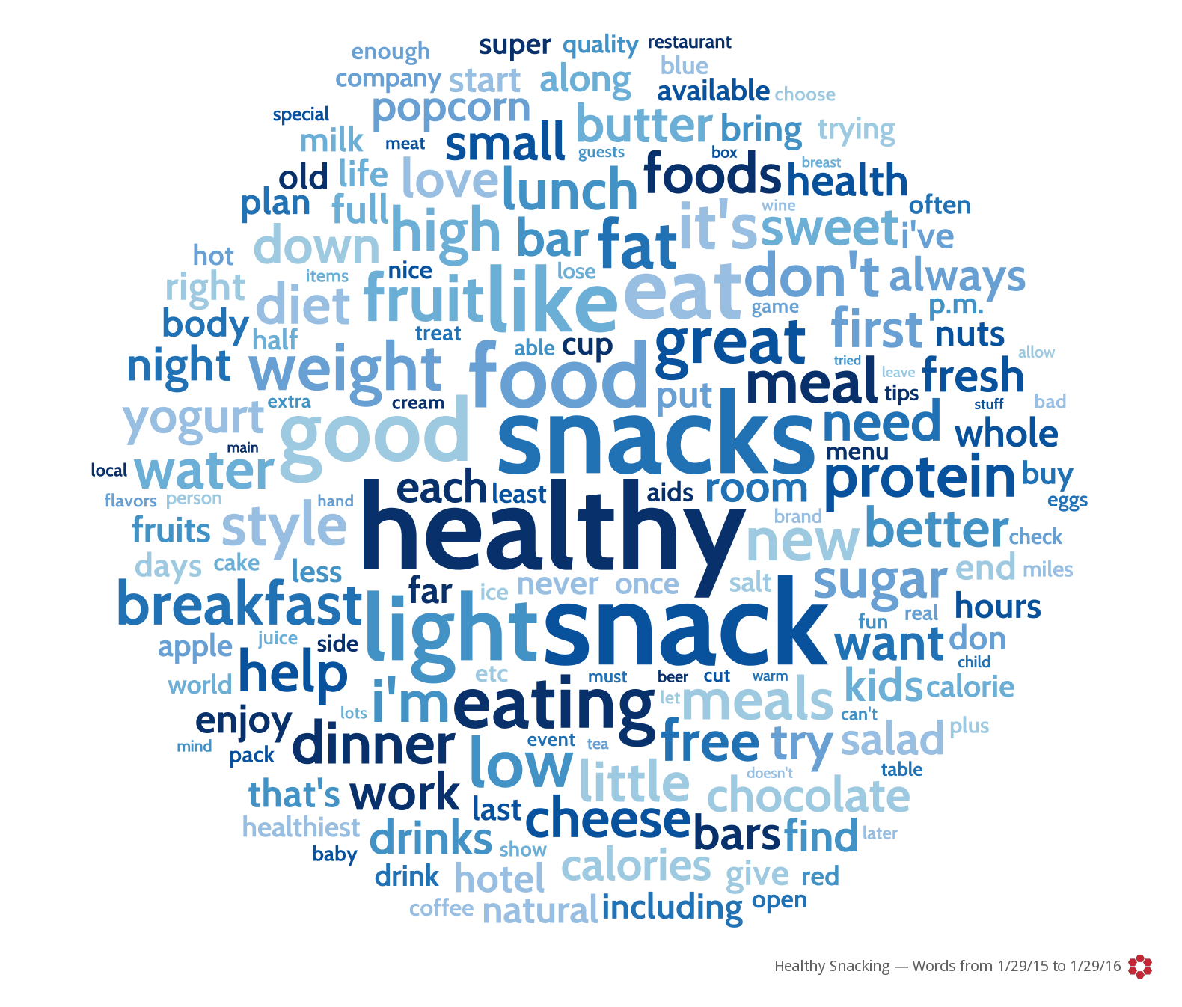

When examining the repeated words, it is important to note several keywords that should be used in conjunction with the Dark Chocolate Almond THINaddictives: protein, light, snack, chocolate, quality, milk, nuts, sweet, weight, natural, whole, health, etc. When taking a look at how some of these words come together in clusters, it becomes clear that these postings are centered on eating well between meals (or throughout the day), weight loss foods, natural ingredients, and light snacks. The most popular hashtags for the posts were: #healthy, #snack, #gotitfree, #protein, and #snacks.

***Analysis of Health Magazine Nonni’s Through Search Engines***

In addition to using Crimson Hexagon to audit the social media coverage for Nonni’s biscotti and THINaddictives products, we also turned to search engines. While Crimson Hexagon was a useful tool for reaching information on social media targets, the focus of the search engine criteria was narrower. We specifically looked for health magazine coverage and any products in the Nonni catalogue, thus the search phrase that we used was: Health, Magazine, and Nonni’s. This search was to determine the professional response to THINaddictives instead of the social.

The results that returned from the search engine were actually quite decent. Aside from links back to the Nonni’s website, online retailers (Amazon, Walmart, Target, etc.), and references within health blogs, there were a few magazines that referenced Nonni’s products. This included Shape, Fitness, Cooking Light, and Health magazine. These articles appeared in their respective magazines since 2013 and all were quite positive. The articles listed the products as some of the best guilt-free desserts, the best food you can buy at gas stations, the best store-bought foods, the best sweet snacks, or the top snack to satisfy your sweet tooth under 80 calories. These positives examples are a good indication of where to position the new Dark Chocolate Almond THINaddictives.

* <http://www.fitnessmagazine.com/recipes/food-awards/healthy-desserts/>
* <http://nonnis.com/thinaddictives-in-the-april-issue-of-health-magazine/>
* <http://www.cookinglight.com/cooking-101/essential-ingredients/best-store-bought-snacks/thinaddictives-pistachio-almond-thins>
* <http://www.today.com/health/shapes-snack-awards-popcorn-jerky-frozen-yogurt-more-1D79887278>
* <http://www.shape.com/healthy-eating/diet-tips/best-bites>
* <http://www.msn.com/en-us/health/nutrition/the-15-best-foods-you-can-buy-at-a-gas-station/ar-BBk6Nci>

1. **Conclusions and Newsworthy Ideas**

***Conclusions***

After conducting the media audit through Crimson Hexagon and conventional web searches, we were able to obtain valuable insights that will allow us to develop a strategic media campaign for our client’s new product.

First, consumers relate THINaddictives with a healthy, low calorie and natural product. As the results from Crimson Hexagon show, when thinking about healthy snacking people think of protein, chocolate and nuts, all of which are related to Nonni’s new Dark Chocolate Almond THINaddictives. Therefore, making it possible for us to position the new product as a healthy, guilt-free treat. Conventional web searches also support this idea as combining the words “Nonni’s” and “healthy” result in numerous magazine articles that talk about the product’s positive traits and healthy, guilt-free attributes.

Second, both *Nonni’s THINaddictives* and *healthy snacking* are topics that receive most of their media coverage from Twitter, showing an immense opportunity for our campaign to target other social media channels. As the analysis demonstrated, spikes in conversation occur during the launch of new products and contests. If we develop a campaign around not just one but various events, we will be able to maintain ongoing conversations throughout the year and generate greater amount of earned media.

Finally, the study shows that the majority of posts on social media come from female adults, and most of these are generated in specific states such as New York, Texas, California and Florida. These findings are closely aligned with Nonni’s demographics and should be considered when establishing the target audience of our campaign.

Following these insights and keeping the objectives in mind, we will be able to come up with big ideas and develop a strategic media relations-driven campaign.

***Idea Generation***

* The first idea that we would like to implement is the sponsorship of a short distance run or marathon in each of the three key markets that align with the target demographics. Some examples would be the Women Rock 5K, 10K and Half Marathon which is held in Chicago and Dallas, the Dirty Girl Mud Run in New York City, or each of the main marathons held in the markets. Sponsorship for these races can range from several thousand dollars upwards and can include targeted marketing campaigns where product can be placed in gift bags or handed out at the finish line. There are also some packages that Nonni’s could purchase that would put their logo on signs, shirts, and in the programs. The resources needed would include human capital to staff these events, money to purchase the sponsorship package, and marketing material development in addition to the samples and/or coupons that will be handed out at the race. In addition to sponsoring the event, we would also like to feature the social media tagline #IDeserveANonnis so that people who finish the race can post on their Instagram, twitter, and Facebook. People who finish the race and include a tagline on a social media platform will receive a coupon for a box of Nonni’s (or buy one get one free). This would be a great exercise to increase brand awareness and introduce the product to our target audience.
* The second big idea that we would like to implement is a spiritual successor to a campaign that was run with the introduction of THINaddictives. In 2013, Nonni’s had a campaign that was called “Get Addicted to…” playing off the word addictive in the product name. Their campaign involved the company posting several videos/tweets about people addicted to spinning, running, etc. Since Nonni’s THINaddictives have been named by many health magazines as a good treat to satisfy sugary cravings, we would like to position the Dark Chocolate Almond THINaddictives in the same vein. The social media campaign that we would like to employ would ask our target audience to tag themselves after finishing or achieving sweet victories in life. Why do you deserve a Nonni’s? We would encourage people to post #IDeserveANonnis after working out, completing a race, going to a doctor, passing a driver’s test--the possibilities are endless and can be whatever our customer’s feel are the sweet victories in life. We will position the Dark Chocolate Almond THINaddictives as a guilt-free indulgence that are a treat or reward. By posting this message, we can send them either a coupon for buy one get one free or other health related prizes. In their 2013 campaign, Nonni’s rewarded the social media postings with FitBits, swimming goggles, and other prizes. The resources needed would be to have the Nonni’s social media team implement the campaign--whether to have online videos, marketing, or other shareable (viral if possible) content that users can share/comment on. We would also need to use some of the budget for coupons and prizes. These activities will increase the use of social media with the Nonni’s catalogue of products.
* The third big idea that we would like to apply would be to appeal to the bloggers. Using Gorkana, we will identify several of the top influencers in the health and weight loss areas and send them a kit that uses some of the previous big ideas to tie everything together. The kit will include a box of each of the new Dark Chocolate Almond THINaddictives, some marketing material about the #IDeserveANonnis campaign (stickers, signs, tchotchkes, etc.) and a special surprise. That surprise will either be an entry form for a 5K, a free yoga/spin/crossfit class coupon, or a gift card for some sort of class that will create the feeling of empowerment or achievement (pottery, life coach, cooking, etc.). The goal of this part of the campaign is to have the blogger write about why they “deserve a Nonni’s.” The kit will also include the aforementioned articles in health magazine listing Nonni’s products as a great snack to eat to curb cravings. We hope that this will create earned media and that the bloggers will mention the high-quality ingredients and how the new THINaddictives are a healthier alternative to other snack foods.