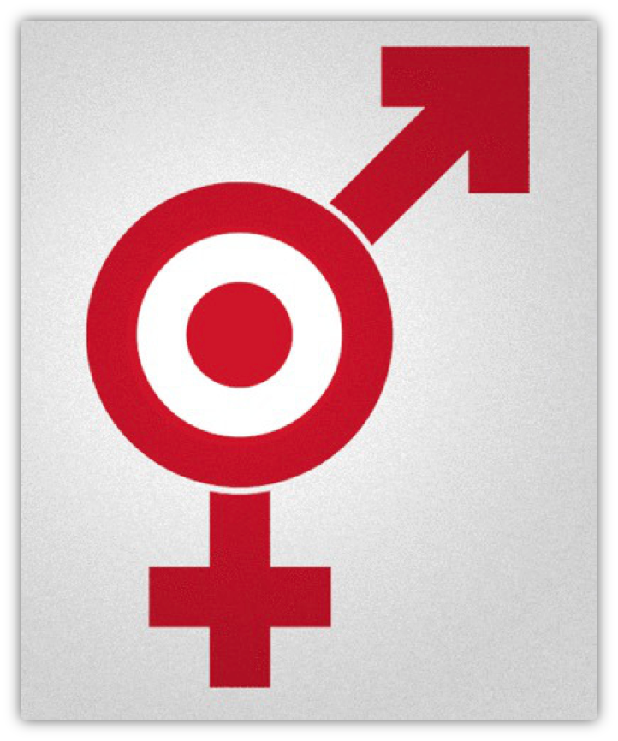

On Target or Off Target?

A case study examining Target’s decision to remove gender labeling from children's toys and bedding

Table of Contents

- Abstract………………………………………………………………………………………......3
- Overview………………………………………………………………………………………….4
- Company Background……………………………………………………………...…..……..5
  - History of Target………………………………………………………………..…......5
  - Target Culture……………………………………………………………..……………5
  - Corporate Social Responsibility……….……...……………………………………5
- The Issue of Gender Stereotyping………….………………………………………..…......6
- Target’s Decision to Go Gender-Neutral……….…………..………………………………7
  - Customer Tweet…………………………………………………………………….....7
  - Target’s Response………………………….…………………………………………7
- Public Reaction………………………..…………………………………………………….....8
  - Traditional Media………………………………………………………………………8
  - Social Media………………………………….……………………………………….10
  - Industry Response………………………….…………………………………….....14
- Timeline of Target’s Response………………………………………………………….....14
- Business Impact………………………………………………………………………….…...15
  - Financial Impact…………………………………………………….…………..……15
  - Reputation Impact……………………………………………....……………………16
- Conclusion……………………………………………………………………………….…….16
- References…………………………………………………………………………………......17

Abstract
Customer feedback plays an important role in steering a company’s success. As as advocated by the Arthur W. Page Society, a company should stay aware of public reaction to products, policies and practices (Arthur W. Page Society, n.d.). In August of 2015 Target made a bold decision to listen to its customers’ growing complaints regarding the gendered signage in its stores. This case study examines Target’s actions regarding the customer feedback and how the company sought to fix the issue, which aligned with the company’s core values of inclusiveness and open-mindedness. The case outlines the public and industry response to the announcement, highlights the importance of social media in customer experience, and the role of corporate social responsibility policies to inform decision-making.

Overview
Target Corporation, the second largest discount retailer in the United States, announced in August 2015 that it would remove all gender designations and labels from many of its aisles including children’s toys and bedding. The decision was announced on Target’s corporate website A Bullseye View, explaining why some gender-based signs, such as the ones placed in the kids’ toys and bedding sections, were irrelevant and therefore would be removed. “We know that shopping preferences and needs change...suggesting products by gender is unnecessary,” wrote the company in their website statement (Target Corporation, A Bullseye View, News and Features, 2015).
This initiative was intended to promote gender equality and remove stereotypes created around children’s toys. Target joined other large retailers implementing this practice such as Amazon and Wal-Mart who removed all gender-based categories from children’s toys earlier in 2015 (Racine, 2015). Target’s decision received significant coverage in various media including Ad Week, USA Today, Huffington Post, The New York Times, Buzzfeed and other major news outlets, blogs, and social media.

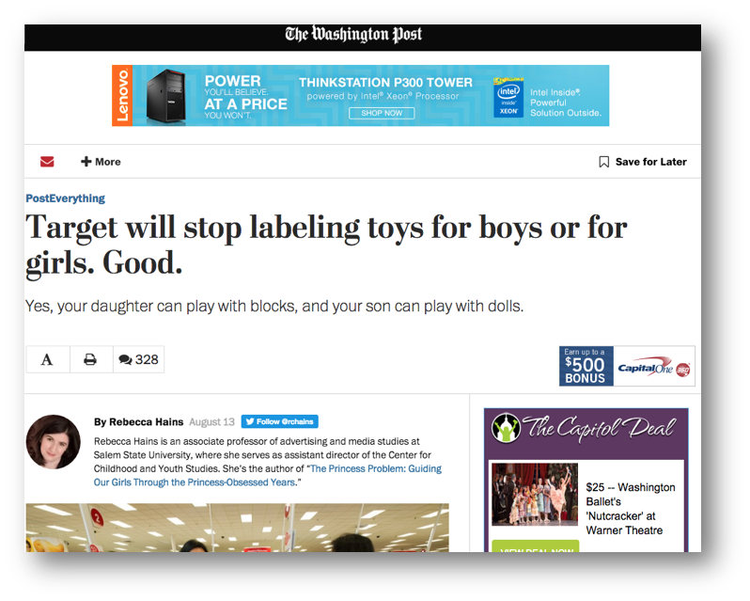
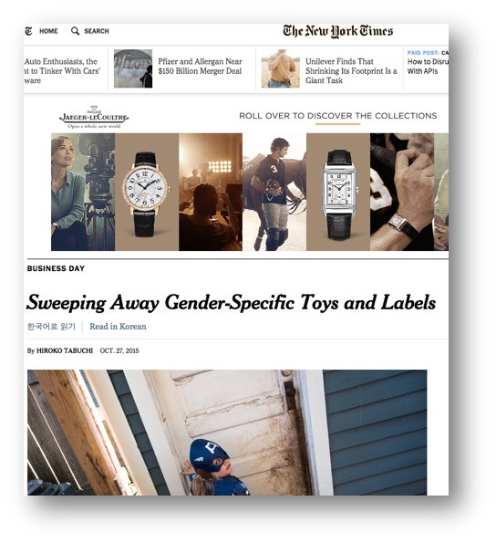
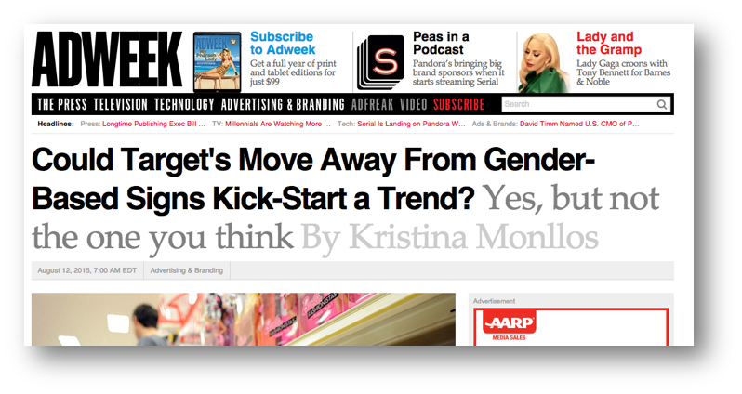

Company Background
History of Target
George Draper Dayton started Goodfellow Dry Goods in 1902, changed its name to Dayton Dry Goods Company in 1903 and shortened the moniker to Dayton Company eight years later in 1911. Fifty-one years later, in 1962, the organization opened its first Target store, modeled as a discount version of the department store. By the 1970s, Target became the leading producer of revenue for the corporation, with annual sales reaching $1 billion right before the 1980s. Today, Target boasts nearly 1,800 stores across the country, employs 347,000 people worldwide, and recorded more than $72 million in revenue in 2013 (Target, Corporate Fact Sheet, n.d.).

Target Culture
Corporate culture refers to "a set of norms and values that are widely shared and strongly held throughout the organization" (O'Reilly & Chatman, 1996). These values shape an organization’s identity (Schreiber, 2011). The Arthur W. Page Society refers to corporate culture as “character” and defines it as an organization’s unique identity. It is the purpose, mission and values that differentiate one organization from another and guide the daily decisions of its employees (Arthur W. Page Society, 2012).
Target prides itself on creating a workplace where “the pace is fast, the atmosphere is fun and the people are friendly.” (Target Corporation, A Bullseye View Culture, n.d.). The company encourages a culture where everyone is valued and rewarded for their efforts and hard work; it recognizes the uniqueness of each individual and cultivates a diverse and inclusive culture. (Target Corporation, Purpose and Beliefs, n.d.)
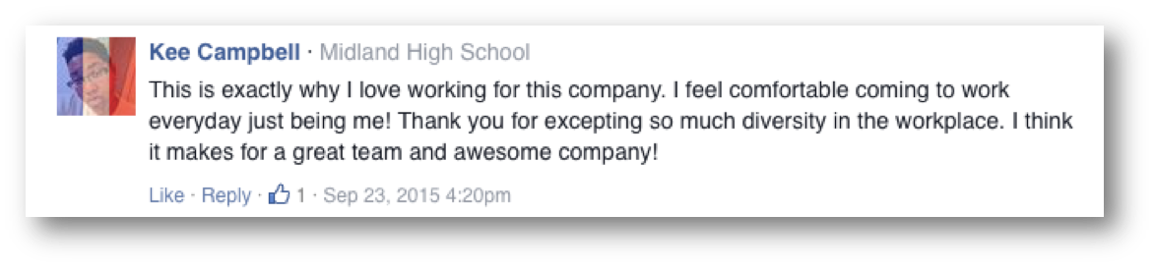
Source: A Bullseye View

Target actively demonstrates its values in a real-life context. Two examples of this are the company’s support of the Equality Act, (Target Corporation, A Bullseye View, News & Features, 2015), and the company’s pro-breastfeeding stance that explicitly forbids employees from shaming women for feeding their kids (takepart.com). “Inclusivity is a core belief we celebrate at Target...From our partnerships with organizations like the Human Rights Campaign (HRC), to our volunteer efforts, and even the products we sell. We want to be a champion for an inclusive society by using our influence and resources to support equality in the communities where our team members and guests live and work” (Target Corporation, A Bullseye View, News & Features, 2015).

Corporate Social Responsibility
As mentioned on its corporate website, Target’s CSR actions are committed to a variety of areas including education, sustainability, health and well-being, responsible sourcing, safety and

preparedness, team members and volunteerism. The company values “its legacy of responsible corporate citizenship, ethical business practices, environmental stewardship and generous community support” (Target Corporation, Fact Sheet, n.d.). Each year, the company donates 5 percent of its profit to communities through grants and has created a large variety of programs to support specific needs (Target Corporation, Corporate Social Responsibility Press Releases, n.d.).
In order to achieve its goals and build strong, healthy and safe communities for its stakeholders, Target works hand in hand with partners and other organizations. Some of Target’s social responsibility initiatives that took place between 2014 and 2015 include:

- In October 2015, as part of Target’s focus on wellness solutions, the company partnered with the U.S. Fund for UNICEF to empower kids to get active and save lives.
- In February 2105 Target announced it would double the size of its “Made to Matter- Handpicked by Target” collection. These are all natural, organic and sustainable brands that will introduce new products and make them more accessible to guests.
- In March 2014, Target and Major League Baseball teamed up to engage guests and fans in celebrating the nation’s teachers and inspire kids’ excitement for education.

The Issue of Gender Stereotyping
In consumer culture, sexism and gender identity are very hot subjects. However, concern for these ideas is not just a passing fad. In regards to childhood development, the gendered messaging children receive as they grow up has a deep psychological impact on their personalities and sense of self (Psychology Today, n.d.). As outlined on the American Academy of Pediatrics website, between the ages of two and four, children are able to take in vast amounts of subtle and blatant cues from parents, media, fellow children, and toys regarding what is the expected behavior of their respective “gender roles” (healthychildren.com).
Recently, the public has grown more aware that enforcing traditional gender roles – or gender stereotyping— in children may have damaging long-term effects on those children later in life. In their paper “Lingering Effects: Stereotyping Threat Hurts More Than You Think” researchers Inzlicht, Tullett, Legault and Kang (2011) studied stereotyping in adults. Their findings indicate that stereotyping--race, sexuality and gender--lead to poor work performance, lack of confidence, and stunted careers.
One way in which a child is first introduced to gender stereotyping is through toys. Traditionally, toys are marketed to and categorized for “boys” and “girls” respectively. Gender Spectrum, a leading online resource for understanding gender in children and teens (endorsed by the Human Rights Society, one of Target’s partners) elaborates on the concept: “Gender is closely monitored and reinforced by society. Practically everything in society is assigned a gender—toys, colors, clothes and behaviors are just some of the more obvious examples.” This type of marketing communicates specific gender expectations, which do not necessarily align with the child’s personality. With this understanding in mind, it should come as no surprise to see an increase in gender-neutral toys and labeling.

Target’s Decision to Go Gender-Neutral
Customer’s Tweet
On June 1 2015, while shopping for toys at Target, mom and feminist blogger Abi Bechtel happened to notice the verbiage on one of the aisle signs. The sign, located in the toys section, read “Building Sets” and “Girls’ Building Sets.” In her own words, “It seemed to imply that if ‘building sets’ are for kids, and ‘girls’ building sets’ are for girls, then ‘girls’ is a distinct category from ‘kids.’ Here was one more piece of visual rhetoric telling my sons that boys are normative, and girls are other” (Bechtel, 2015). Bothered by the implications, Bechtel tweeted a picture of the sign with the caption, “Don’t do this, @Target”.
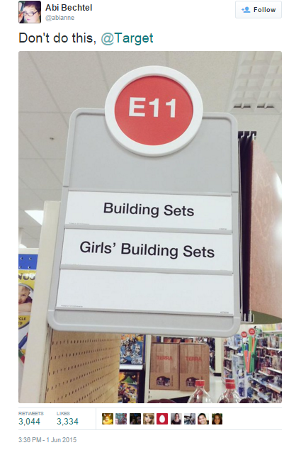

Source: twitter.com/abianne

The post soon made headlines. While Bechtel was not the first to take issue with the gendered language in the signage, Bechtel’s tweet caused a social media fire. It was retweeted and favorited over three thousand times respectively by Target customers, echoing their support for Bechtel’s message. In an interview with NewsyBusiness, Bechtel reiterated that she “would love to see girls play with fire trucks and Star Wars and all of the building sets.” (NewsyBusiness, 2015).

Target’s Response
On Friday, August 7 Target took a nontraditional approach and via the company's blog, announced it would be moving away from gender-based signs. The major retailer showed confidence by only choosing to use an owned media channel to announce its decision. As a result of the announcement, the company generated a high volume of earned media interest and attention.

August 7, 2015

Shop a Target store and chances are you’ll discover something exciting. Maybe it’s a quick-fix mix & match meal your family will love, or the perfect pair of earrings to complete that new outfit. We love hearing our guests talk, tweet and post about their unexpected Target finds. To help guests navigate our stores, we put a lot of thought into how things are organized. As part of that, we use signs and displays specially designed to help guests get through the store efficiently while pointing the way to more inspiration and great products.
But we never want guests or their families to feel frustrated or limited by the way things are presented. Over the past year, guests have raised important questions about a handful of signs in our stores that offer product suggestions based on gender. In some cases, like apparel, where there are fit and sizing differences, it makes sense. In others, it may not. Historically, guests have told us that sometimes—for example, when shopping for someone they don’t know well—signs that sort by brand, age or gender help them get ideas and find things faster. But we know that shopping preferences and needs change and, as guests have pointed out, in some departments like Toys, Home or Entertainment, suggesting products by gender is unnecessary.
We heard you, and we agree. Right now, our teams are working across the store to identify areas where we can phase out gender-based signage to help strike a better balance. For example, in the kids’ Bedding area, signs will no longer feature suggestions for boys or girls, just kids. In the Toys aisles, we’ll also remove reference to gender, including the use of pink, blue, yellow or green paper on the back walls of our shelves. You’ll see these changes start to happen over the next few months.
We thank guests all the time for challenging us to get better at what we do and take the shopping trip to new levels. We’re always listening, and your thoughts and ideas help us make Target, your Target, a better place.

Public Reaction
Traditional Media
In the week following the announcement, Target’s decision became a popular topic and was picked up by Fox and Friends, The New York Times, Daily Beast, The O’Reilly Factor, and other news outlets. Rebecca Hains in a Washington Post story accurately summarized the divided response: “For every progressive parent celebrating the demise of the pink and blue aisles, a conservative parent is furious that Target has taken the other side in this culture war. Their outrage seems to stem from a widespread misunderstanding of the concept of ‘gender neutral’ in a marketing context.” (Hains, 2015)

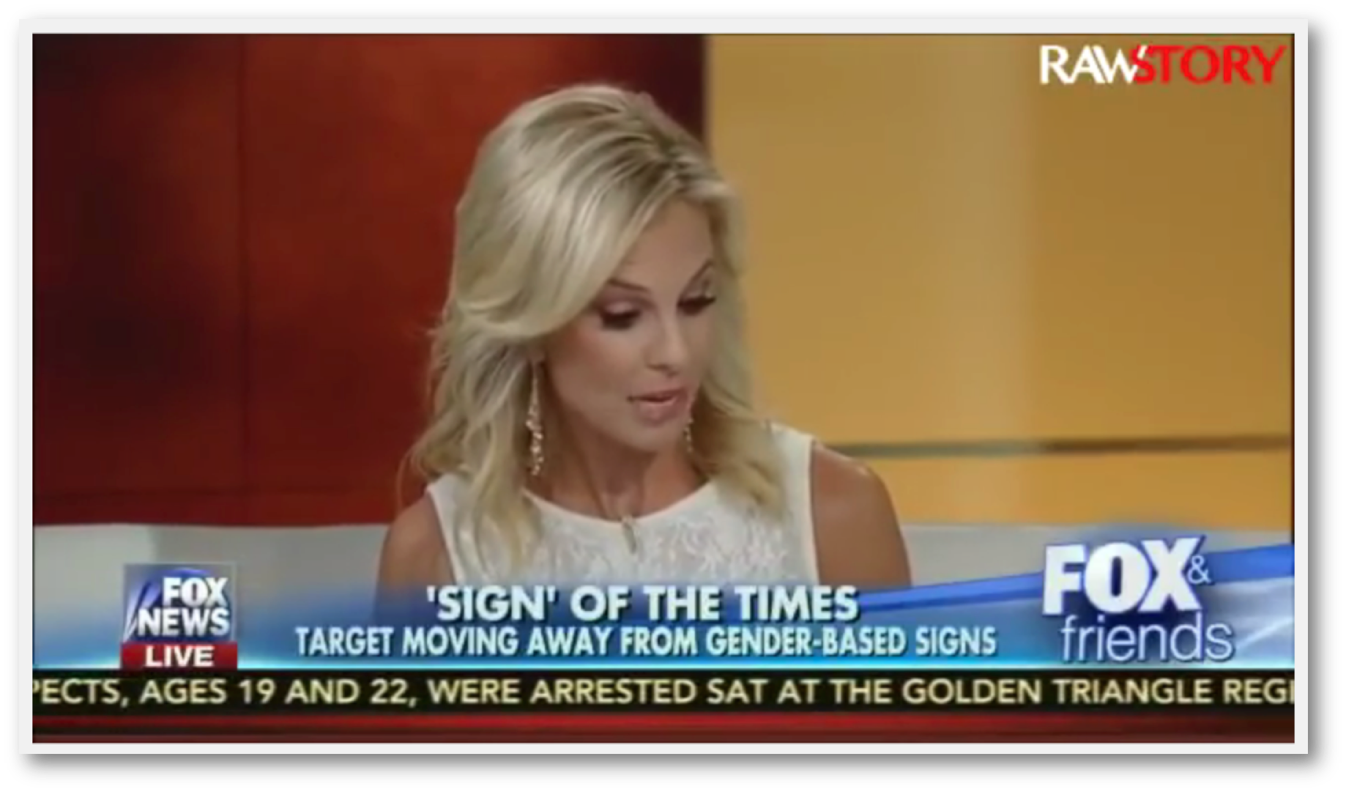
Source:http://www.rawstory.com/2015/08/

A story appearing in Huffington Post Gay Voices on August 11 quoted Molly Snyder, Target’s group manager for public relations, "we recognize by coming out and making these couple of changes that people are going to have a wide variety of opinions.” (Sieczkowowski, 2015)
A story on Good Morning America featured Rachel Simmons, the co-founder of Girls Leadership, a non-profit organization dedicated to empowering girls, who stated she felt the announcement was monumental. “It's a huge deal that Target is going gender-neutral because Target is a trendsetter, retailers have an incredible opportunity here. They're opening up a whole world of possibility for these kids.” (ABC News/Good Morning America, 2015)
A New York Times article by Erika Weisgram poked fun at critics of the move, and offered tongue in cheek labels for Target to consider including “violence, aggression and weapon-use.” Greisman ended her article heralding the decision as one with a huge impact on children and society and our ability to make choices based on things a child likes, not based on gender labels. (Weisgram, 2015) She also concluded that retailers should be able to select the labels that they like, but should refrain from labeling children:
“When toys aren’t artificially categorized, boys and girls can grow by playing without the burden of stereotypes, and without feeling ashamed by a love for a toy or movie that crosses imaginary, socially constructed gender lines. Children of all genders can make choices based on their own individual strengths, abilities and interests, and stores can label their toy aisles however they like — as long as they’re not also labeling our children.”

Months after Target’s announcement, an article by Hiroko Tabuchi, “Sweeping Away Gender-Specific Toys and Labels”, appeared in The New York Times. The article notes a shift in product labeling across brands and companies, first mentioning Target, and subsequent announcements of toys and Halloween costumes labeled “for kids” instead of labeled for girls or boys at Disney Store and Amazon, and notes Mattel’s new action figure line based on a DC Super Heroes Girls franchise. (Tabuchi, 2015)
Although Target is firm on adopting the gender-neutral philosophy, it has also been criticized for being late to the game, with Wal-Mart and Toys ‘R’ Us having already made the move to gender-neutral labels. According to a 2015 Star Tribune article (Kumar, 2015),
“Toys ‘R’ Us in 2013 agreed to remove gender specific signage from stores in the United Kingdom amid pressure from groups there. It has a similar U.S. policy, a spokeswoman said in an e-mail Friday. “There are no gender-specific toy sections in our stores,” Kathleen Waugh, vice president, corporate communications, said in the e-mail. “Toys are merchandised by product category, so customers can easily see the breadth of assortment.”

Social Media
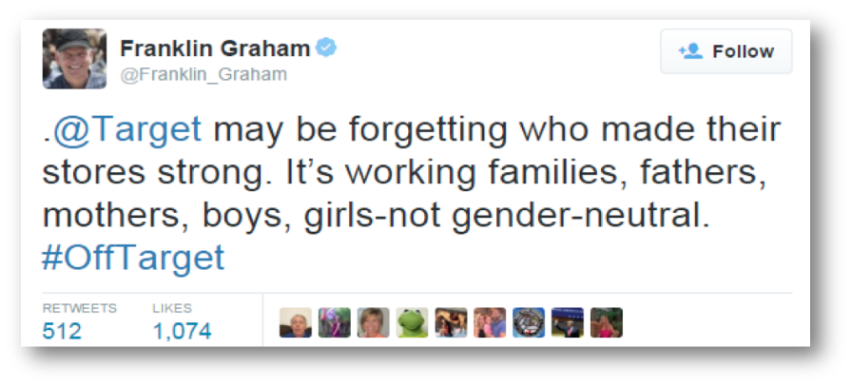
The news also drew criticism and support in the blogger community. Conservative Christian blogger Matt Walsh boldly proclaimed in his blog, “Yes, Target, I do want my daughter to conform to her gender,” and outlined the role of gender in traditional family values and Christianity, and how Target undermined these values with the removal of gender labeling in stores. On Fox News, Reverend Franklin Graham, president of the Billy Graham Evangelistic Association, called for a boycott of Target, stating “this whole gender neutral business has gone too far...I’d get back to doing your business...with the American family in mind.”

Source: Twitter.com/target

Additionally, Target received heavy backlash from consumers who were not happy with the overall idea and took to social media to voice their disapproval.
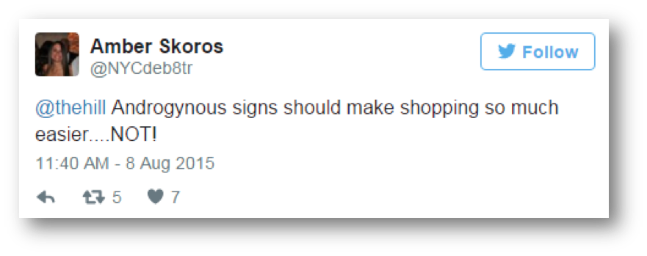

Source: Twitter.com/target

Consumers began weighing in on Target’s Facebook page as well. Comments were both positive and negative. Conservative groups that opposed Target’s decision adopted the hashtag: #OffTarget, while others reiterated their support.
A social media user, Mark Melgaard, began responding to those who disagreed with the decision on Target’s Facebook page. He created a fake Facebook account called “Ask for Help” positioning himself as a Target customer service representative, complete with a Target bullseye logo for a profile photo. His responses, which were inflammatory, dismissive, and not what consumers typically expect from a corporation, drew a large amount of media attention.

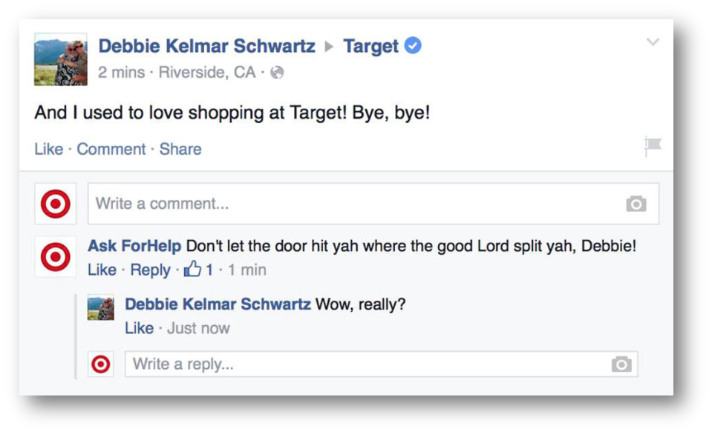
Source: facebook.com/target

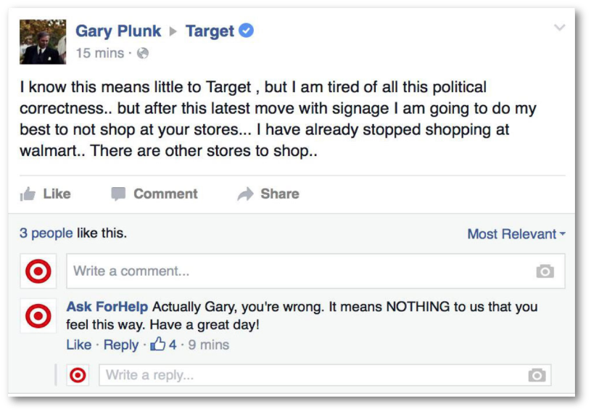
Source: facebook.com/target

After nearly 16 hours of “trolling”, the fake account was shut down and Target issued the following statement to Ad Freak:
"At Target, we are committed to providing outstanding guest service to our guests wherever we engage with them—in our stores, online, or on our social pages. Clearly this individual was not speaking on behalf of Target. Should guests ever have questions on whether a communication from Target is legitimate, we encourage them to reach out to guest relations at 1-800-440-0680."

Just hours later, Target posted a photo on Facebook of troll toys with the caption, “Remember when Trolls were the kings of the world? Woo hoo! They’re back and only at Target stores.” Social media user responses ranged from “well played” to sarcastic posts like “If you aren’t going to tell me which troll is the boy and which one is the girl, how can I shop at Target?”

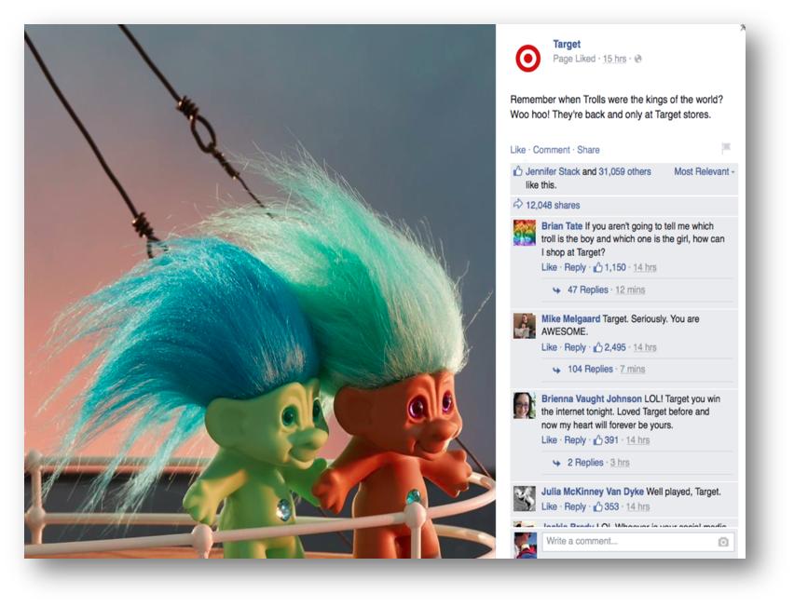

Source: facebook.com/target

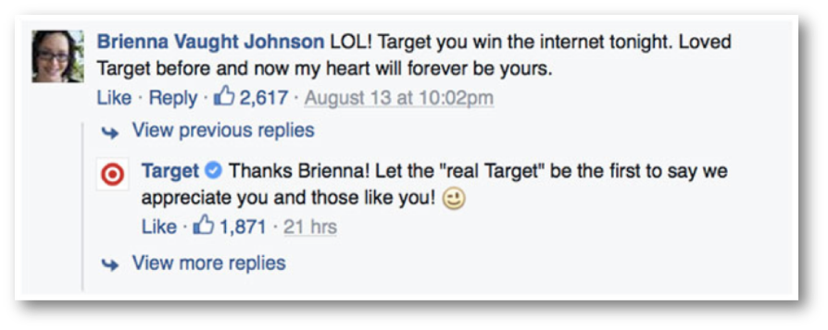

Source: facebook.com/target

Social listening revealed trends in conversation around the announcement. Conversations centered on gender roles, labels, and signs. The following wheel, generated from Crimson Hexagon, shows trends in conversation from June 1 through November 21, 2015.
The announcement also generated a high volume of social media activity. The following chart, generated from Crimson Hexagon, demonstrates the spike in conversation throughout the month of August. The second major spike in conversation around October 15 around Target is unrelated to the gender label issues and was prompted by store closures in Canada.

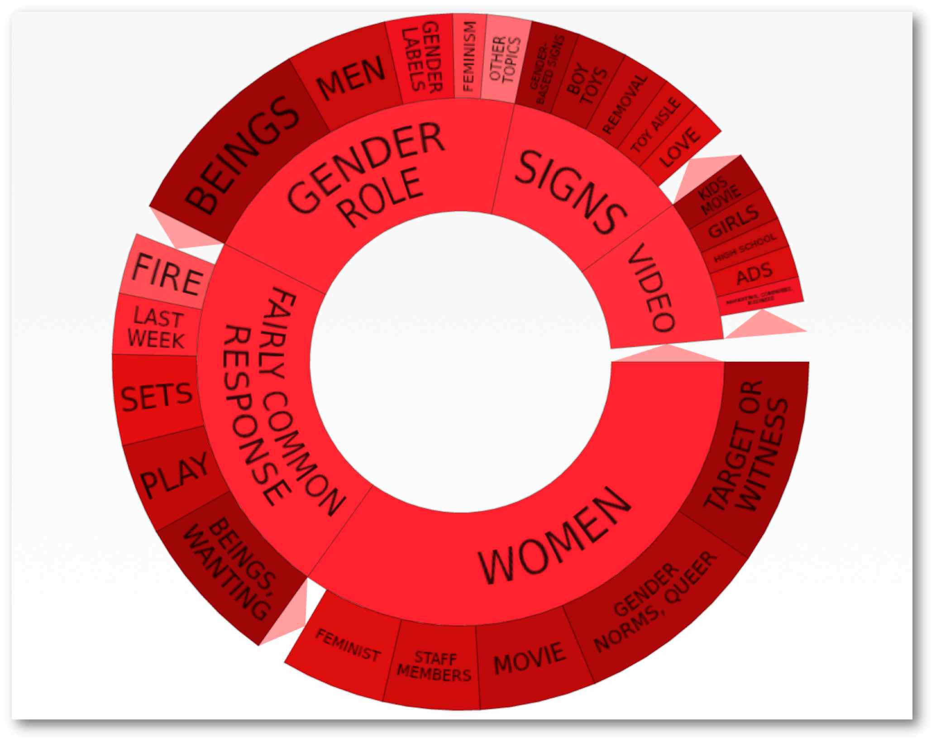

Source: Crimson Hexagon

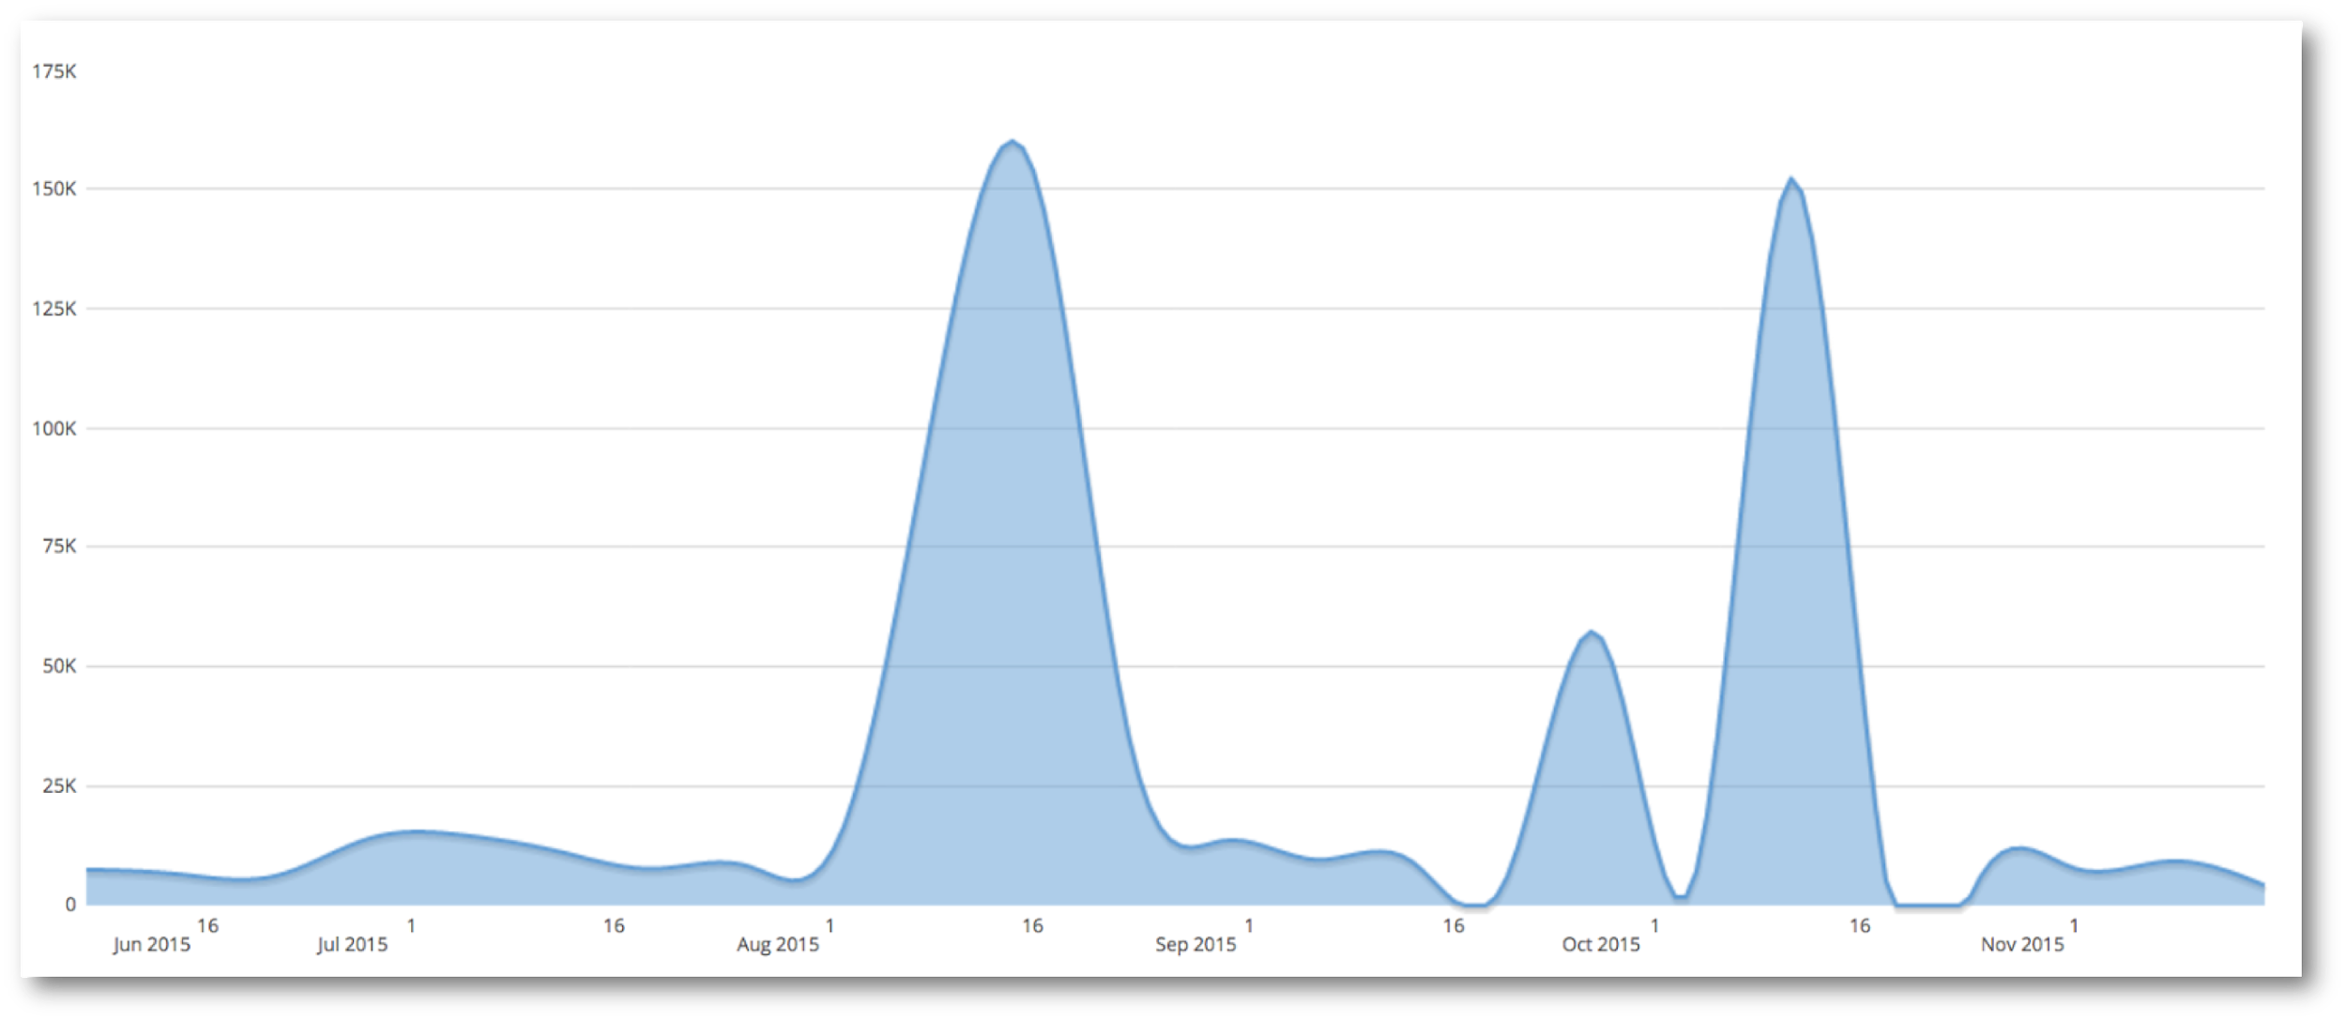
Source: Crimson Hexagon

Industry Response
In an in Ad Week story the week after the announcement was made, public relations professionals interpreted the move as not just removing gendered signage, but one of Target listening to customers and making the changes they demand (Monllos, 2015). “Branding experts see it as a winning move for Target. And more than a trend toward gender-neutral signage, it signals a shift in the way brands react to shoppers on social media—ultimately elevating the importance of customer feedback.” said Monllos.
Mary Beth Keetly, chief marketing officer of PM Digital, stated in the article, "ultimately the main drivers of this change are today's customers," she said. "They've demonstrated to the brand that certain values and experiences are of high importance to them, and by answering that need, Target is further shifting the focus to its customer." (Monllos, 2015) The article further lays out the power of everyday consumers and the ability for brands to interact, make a change to satisfy customers, and to uphold the values and beliefs of those customers to positively impact business perceptions by consumers.
Target has employed its core values to fuel good business decisions which are aligned with its principles and beliefs. By making decisions informed by this foundation, Target has shown commitment, taken a bold point of view, and ultimately made its customers happy.

Timeline of Target’s Response

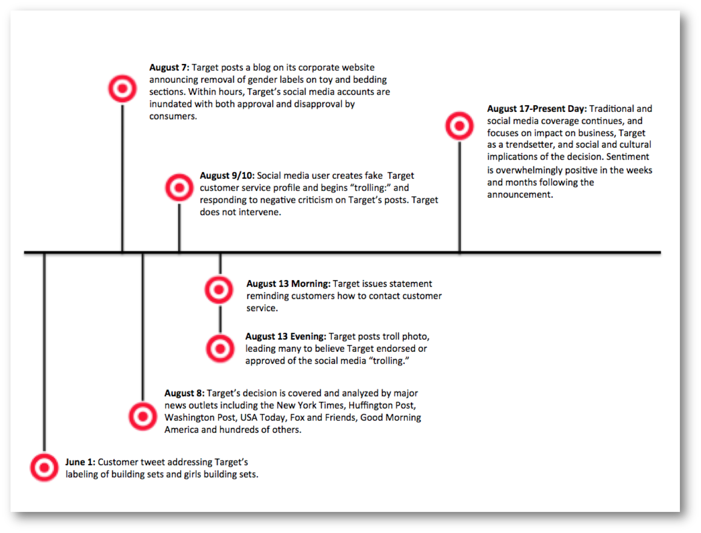

Business Impact
Financial Impact
Target’s announcement came midway through the third quarter of 2015. During this time, Target’s stock fell briefly after the announcement, but quickly rose again and stayed consistently higher than the quick dip for the next three months. Target’s stock also performed higher than competitor Wal-Mart’s did during that same period of time. In an article from Invest Correctly on November 13th, it was reported that in the last four quarters, Target’s earnings have topped “between 2.7% and 14.9% above expectations” (Shah, 2015). The article goes on to reiterate that Target “is well placed to take advantage of the estimated [holiday] season’s sales” due to the company’s placement as an online retailer in conjunction with its discount stores.
On November 18, 2015, Target reported its third quarter 2015 earnings showing adjusted EPS of $0.86 was above the midpoint of the company’s expectations of $0.79, comparable sales growth of 1.9 percent was near the high-end of the company’s expectations and traffic growth of 1.4 percent. Comparable sales in signature categories such as style, baby, kids and wellness, grew more than 2.5 times. (Target Corporation, A Bullseye View, Releases, 2015.)

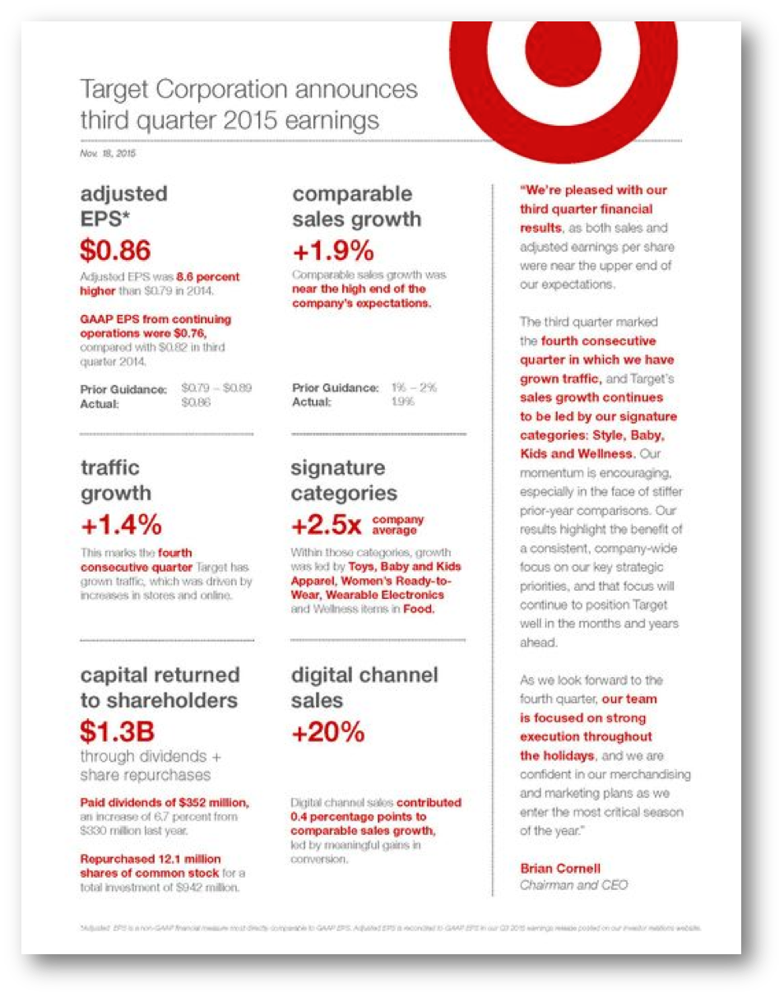

Source: Target.com

While Target’s decision to end gendered labeling may have upset a few outspoken detractors, the company’s bold move has not had adverse effects.

Reputation Impact
Months after the decision was announced, Target is still being both praised and criticized by the public. The company’s decision was heavily discussed as soon as it was published, but Google searches in December of 2015 yield articles regarding gender labels, Target, and the impact on American retailers and consumers.
By taking on the gender-neutral market initiative, Target has demonstrated that it heard customers who disapproved of the gender-based labeling in stores. According to social analytics firm Brandwatch, Target has accumulated nearly 20,000 mentions on the Internet since August 4, with nearly 90% of these mentions happening since the announcement was released. Brandwatch also found that the conversation has been overwhelmingly pro-Target, with twice as many positive mentions as negative.

Conclusion
Target’s move is one which was not unique to the retail landscape as other competitors had already moved away from gender labeling. However, Target’s positioning and rationale for making the decision was unique and has impacted the retail landscape. Target positioned the move as a demonstration of its core values, and its emphasis on listening to its customer.
Recognizing that the issue began on social media, Target responded quietly on its website, and continued to interact with customers and fans throughout all of its social media platforms. “The important takeaway from Target’s announcement is that brands should never underestimate the power of simply saying, “We heard you, and we agree.” The customer may not always be right, but recognizing and valuing their opinions can go a long way in building credibility, trust and enthusiasm for your brand” (Dellaquila, 2015).

References

ABC News/Good Morning America (2015, August 10). Target Moves Toward Gender-Neutral Store Signage. Retrieved from https://gma.yahoo.com/target-moves-toward-gender-neutral-store-signage-135027992--abc-news-parenting.html#

Allen, S. (2015, August 14). The Daily Beast. Bigots Lose It Over Target’s Boy Toy Policy Retrieved from http://www.thedailybeast.com/articles/2015/08/14/bigots-lose-it-over-target-s-boy-toy-policy.html

Arthur W. Page Society. (2012). Building belief: A new model for activating corporate
culture & authentic advocacy. Arthur W. Page Society. Retrieved from http://www.awpagesociety.com/wp-content/uploads/2012/11/Building-Belief-New-Model-for-Corp-Comms.pdf

Arthur W. Page Society. (n.d.). Seven Proven Principles That Guide Our Actions & Behavior. Arthur W. Page Society. Retrieved from
http://www.awpagesociety.com/about/the-page-principles/

Bechtel, A. (2015, August 10). Time. Target Finally Listened to My Viral Tweet About Boys’ and Girls’ Toys. Retrieved from http://time.com/3991166/target-viral-tweet-about-boys-and-girls-toys/

Brewer, H. (n.d.). Health Guidance List of Gender Stereotypes. Retrieved from http://www.healthguidance.org/entry/15910/1/List-of-Gender-Stereotypes.html

Castleberry, G. (2015, August 10). Gospel. Gender. Flourishing: The Council on Biblical Manhood & Womanhood. Missing the Target: Some Brief Thoughts on Target’s Cultural Capitulation. Retrieved from http://cbmw.org/topics/complementarianism/missing-the-target-some-brief-thoughts-on-targets-cultural-capitulation/

Centers for Disease Control and Prevention (2014, November 12). Lesbian, Gay, Bisexual, and Transgender Health: LGBT Youth. Retrieved from http://www.cdc.gov/lgbthealth/youth.htm

Centers for Disease Control and Prevention (2013, November). Parents’ Influence on the Health of Lesbian, Gay, and Bisexual Teens: What Parents and Families Should Know. Retrieved from http://www.cdc.gov/healthyyouth/protective/pdf/parents_influence_lgb.pdf

Dellaquila, M. (Fall 2015, Issue 11). Fleishman Hillard: Team True. Target Aims to Please With Gender-Neutral Kids’ Section. Retrieved from http://fleishmanhillard.com/2015/08/true/target-aims-to-please-with-gender-neutral-kids-sections/

Dwyer, L. (2015, July 14). takepart.com. Women Are Going Wild for Target’s Pro-Breast-Feeding-Stance. Retrieved from
http://www.takepart.com/article/2015/07/14/women-going-wild-target-breastfeeding-policy

Edwards, D. (2015, August 10). Raw Story. Fox & Friends panic over Target’s non-gender specific toy labeling: ‘I know it’s going to confuse me.’ Retrieved from http://www.rawstory.com/2015/08/fox-friends-panics-over-targets-non-gender-specific-toy-labeling-i-know-its-going-to-confuse-me/

Engel, M. (2015, August 10). New York Daily News. Target taking down gender-specific signage after social media complaint. Retrieved from http://www.nydailynews.com/life-style/target-gender-specific-signage-article-1.2320483

Gay & Lesbian Advocates and Defenders. (n.d). Wikipedia. Retrieved from https://en.wikipedia.org/wiki/Gay_%26_Lesbian_Advocates_%26_Defenders

Gender and Gender Identity at a Glance. (n.d.). Planned Parenthood. Retrieved from https://www.plannedparenthood.org/learn/sexual-orientation-gender/gender-gender-identity

Gender Identity Development in Children. (2015, November 11). Healthy Children, American Academy of Pediatrics. Retrieved from https://www.healthychildren.org/English/ages-stages/gradeschool/Pages/Gender-Identity-and-Gender-Confusion-In-Children.aspx

Hains, R. (2015, August 13). The Washington Post. Target will stop labeling toys for boys or for girls. Good. Retrieved from https://www.washingtonpost.com/posteverything/wp/2015/08/13/target-will-stop-selling-toys-for-boys-or-for-girls-good/

Homophobia Questionnaire. (n.d.) Frontline. Retrieved from http://www.pbs.org/wgbh/pages/frontline/shows/assault/etc/quiz.html

Inzlicht, M., Tullett, A., Legault, L., Kang, S. Social Issues and Policy Review, Vol. 5, No. 1, 2011, pp. 227-256. Lingering Effects: Stereotype Threat Hurts More than You Think. Retrieved from http://www.alexatullett.com/papers/Inzlicht,%20Tullett,%20Legault,%20&%20Kang%20(2011).pdf

Kellaway, M. (2015, July 16). Advocate. Who are the Trans Teens Lost to Murder and Suicide Whose Stories ‘Haunt’ Caitlyn Jenner? Retrieved from http://www.advocate.com/transgender/2015/07/16/who-are-trans-teens-lost-murder-and-suicide-whose-stories-haunt-caitlyn-jenne
Kumar, Kavita. (2015, August 8). Star Tribune. Target to remove gender-based labeling in toy aisles. Retrieved from http://www.startribune.com/target-to-remove-gender-based-labeling-in-toy-aisles/321063071/

Media Matters for America (2015, August 12). On Fox, Rev. Franklin Graham Calls For Boycott Of Target Over Removing Gender Labels From Some Children’s Products [Video] Retrieved from http://mediamatters.org/video/2015/08/12/on-fox-rev-franklin-graham-calls-for-boycott-of/204915

Monllos, K. (2015, August 12). AdWeek. Could Target’s Move Away From Gender-Based Signs Kick-Start a Trend? Retrieved from http://www.adweek.com/news/advertising-branding/could-targets-move-away-gender-based-signs-kick-start-trend-166315

National Center for Transgender Equality. (n.d.). Wikipedia. Retrieved from https://en.wikipedia.org/wiki/National_Center_for_Transgender_Equality

Newsy Business (2015, June 9). Target Sign For Girls’ Building Blocks Starts Debate. [Video] Retrieved from https://www.youtube.com/watch?v=9WzSgzCWIvc

Nudd, T. (2015, August 13). Ad Week: Ad Freak. Man Poses as Target on Facebook, Trolls Haters of Its Gender-Neutral Move With Epic Replies. Retrieved from http://www.adweek.com/adfreak/man-poses-target-facebook-trolls-haters-its-gender-neutral-move-epic-replies-166364

O’Reilly, Charles and Jennifer A. Chatman, 1996, “Culture as Social Control: Corporations, cults, and Commitment,” in Barry M. Staw and L. L. Cummings, eds., Research in Organizational Behavior, Vol. 18, Greenwich, CT: JAI Press, Inc. Retrieved from http://economics.mit.edu/files/9721

Peterson, J. (2015, November 16). Huff Post Education. 5 Reasons to Teach Gender Equality in Schools. Retrieved from http://www.huffingtonpost.com/joel-l-a-peterson/post_10328_b_8307744.html

Racine, H. (2015, August 9). Bustle. Target Removes Gender-Based Signs in Kids’ Sections & Impressed Twitter Users Are Celebrating. Retrieved from http://www.bustle.com/articles/103030-target-removes-gender-based-signs-in-kids-sections-impressed-twitter-users-are-celebrating

"Sexual Orientation and Gender Identity Definitions | Human Rights Campaign." Human Rights Campaign. N.p., n.d. Web. 22 Nov. 2015. Retrieved from
http://www.hrc.org/resources/sexual-orientation-and-gender-identity-terminology-and-definitions

Shah, V. (2015, November 13). Lot At Stake For Target In Upcoming Holiday Season. Invest Correctly. Retrieved from http://investcorrectly.com/20151113/lot-at-stake-for-target-corporation-tgt-in-upcoming-holiday-season/

Sieczkowski, C. (2015, August 11). Huff Post Gay Voices. Target Angers Customers With Its Stores’ New Non-Gendered Policy. Retrieved from http://www.huffingtonpost.com/entry/target-gender-biased-signs_55c9ffe6e4b0923c12be0f96

Stein, Len. (2015, May 9). Branding Magazine. Where Does Public Relations Fit Into the Customer Experience? Retrieved from http://www.brandingmagazine.com/2012/05/09/where-does-public-relations-fit-into-the-customer-experience/

Schreiber, E, S. (2011, January 12). Reputation. Retrieved from http://www.instituteforpr.org/reputation/

StopBullying.gov (n.d.). Bullying and LGBT Youth. Retrieved from http://www.stopbullying.gov/at-risk/groups/lgbt/index.html

Tabuchi, H. (2015, October 27). The New York Times. Sweeping Away Gender-Specific Toys and Labels. Retrieved from http://www.nytimes.com/2015/10/28/business/sweeping-away-gender-specific-toys-and-labels.html?_r=0

Target Corporation, A Bullseye View, News and Features (2015, August 7). What’s in Store: Moving Away from Gender-based Signs Target Blog [Blog Post]. Retrieved from https://corporate.target.com/article/2015/08/gender-based-signs-corporate

Target Corporation, A Bullseye View (n.d.). Corporate Responsibility. Retrieved from https://corporate.target.com/corporate-responsibility/

Target Corporation, A Bullseye View, Culture. [Video] Retrieved from https://corporate.target.com/careers/culture

Target Corporation, A Bullseye View, News & Features (2015, September 10). Stronger Together: Target Signs on in Support of the Equality Act. Retrieved from https://corporate.target.com/article/2015/09/equality-act

Target Corporation, A Bullseye View, Releases. (2015, November 18) Target Reports Third Quarter 2015 Earnings. Retrieved from http://pressroom.target.com/news/target-reports-third-quarter-2015-earnings

Target Corporation, Corporate Social Responsibility. [Press Releases] Retrieved from http://pressroom.target.com/news?c=18082

Target Corporation, Fact Sheet. Retrieved from http://pressroom.target.com/corporate

Target Corporation, Purpose and Beliefs. Retrieved from https://corporate.target.com/about/purpose-beliefs

Target’s Decision to Remove Gender-Based Signs is Just the Start (2015, August 10). Time. Retrieved from http://time.com/3990442/target-gender-based-signs/

Thomas, E. (2014, September 17). Huff Post Gay Voices. New Target Ad Features Gay Dads, Shuts Out All The Haters. Retrieved from http://www.huffingtonpost.com/2014/09/17/target-same-sex-couple-ad_n_5831862.html

"Understanding Gender." Gender Spectrum. N.p., n.d. Web. 22 Nov. 2015. Retrieved from
https://www.genderspectrum.org/quick-links/understanding-gender/

Understanding Gender. (n.d.). Psychology Today. Retrieved from https://www.psychologytoday.com/basics/gender

Ungar, L. (2015, August 16). USA Today. Transgender people face alarmingly high risk of suicide. Retrieved from http://www.usatoday.com/story/news/nation/2015/08/16/transgender-individuals-face-high-rates--suicide-attempts/31626633/

Walsh, M. (2015, August 13). The Blaze. Yes, Target, I Do Want My Daughter To Conform To Her Gender. Retrieved from http://www.theblaze.com/contributions/yes-i-do-want-my-daughter-to-conform-to-her-gender/

Wardy, M. (2015, August 7). Pigtail Pals & Ballcap Buddies Blog. Target Moves Away From Gendered Signs and Shelving. Retrieved from http://pigtailpalsblog.com/2015/08/target-moves-away-from-gendered-signs-and-shelving/#.VlCNVnvOrfI

Weisgram, E. (2015, August 17). The New York Times. Now That Target Won’t Label Toys By Gender, Some Alternatives. Retrieved from http://mobile.nytimes.com/blogs/parenting/2015/08/17/truth-in-signage-in-the-toy-aisle-after-target-removes-gender-labels-whats-next/?referer=

Welsh, J. (2011, April 18). Live Science. Homosexual Teen Suicide Rates Raised in Bad Environments. Retrieved from http://www.livescience.com/13755-homosexual-lgb-teen-suicide-rates-environments.html

Wong, C. (2015, June 9). Huff Post Gay Voices. Target’s New Pride Commercial Will Make Your Queer Heart Sing. Retrieved from http://www.huffingtonpost.com/2015/06/09/target-take-pride-campaign_n_7545624.html

